From Cloud to Camera: The Rise of Edge Video Analytics

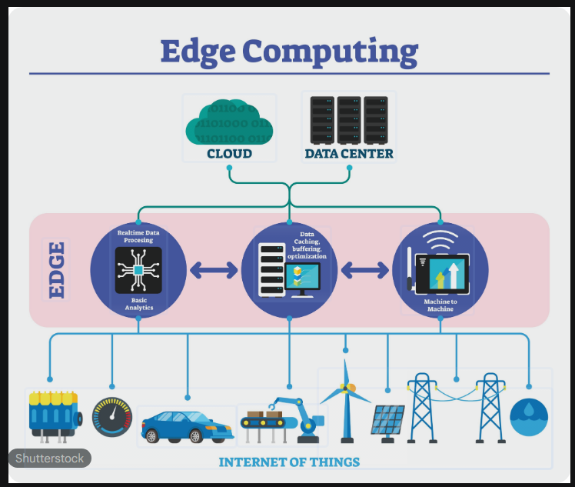

Introduction

The Shift to Edge Video Analytics
The digital world is currently experiencing an absolute explosion of information, and the primary culprit isn't text or photos it’s video. From the cameras embedded in our city streets to security systems and self-driving cars, we are generating a staggering amount of footage every second.
Historically, we’ve relied on cloud computing to make sense of all this data. But sending every single frame to a distant data center has hit a breaking point. It creates a "traffic jam" in bandwidth, causes frustrating delays (latency) when we need instant answers, and raises some pretty serious red flags regarding data privacy.¹
To fix these bottlenecks, we are seeing a major shift toward Edge Video Analytics (EVA). Instead of sending data away to be processed, EVA brings the "brainpower" directly to the source the cameras and sensors themselves. By moving the heavy lifting to the edge of the network, we can get faster, more private, and more efficient insights.¹

Why the Shift Matters
Feature | Cloud-Based VA | Edge Video Analytics (EVA)
Speed | High latency (delays) | Real-time processing
Data Usage | Heavy bandwidth consumption | Minimal data transmission
Privacy | Sensitive data travels over the web | Data stays local and secure
Reliability | Depends on internet connection | Can function offline

Cloud vs. Edge Computing Trade-Offs
Choosing the correct computing paradigm is crucial. Cloud computing offers high throughput and vast storage, but its transmission delay makes it unsuitable for real-time inference. Edge computing, conversely, processes data locally, offering ultra-low latency and higher data security, but is limited by the hardware capacities of local devices.²
Below is a quantitative comparison of Cloud vs. Edge metrics ²:

Latency and Throughput Comparison (Cloud vs. Edge)
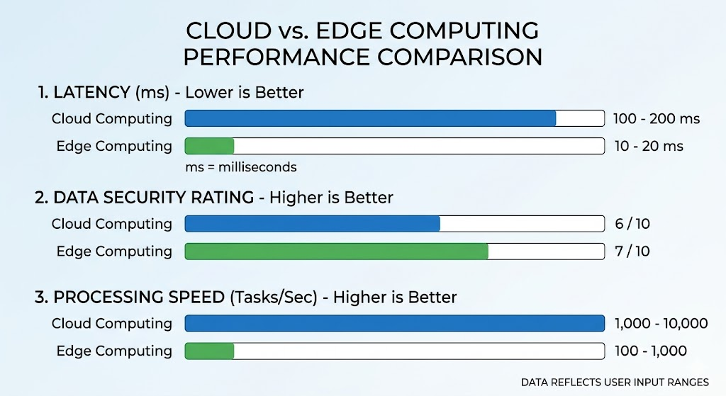

The CETC Architecture and Video Pipeline
Modern architectures have shifted away from binary edge-or-cloud decisions, moving instead toward Cloud-Edge-Terminal Collaborative (CETC) systems.³ CETC allows for tasks to be dynamically distributed based on resources and network conditions.
The execution of real-time video analytics follows a sequential pipeline from photon capture to intelligence extraction.

The Edge Video Analytics Pipeline

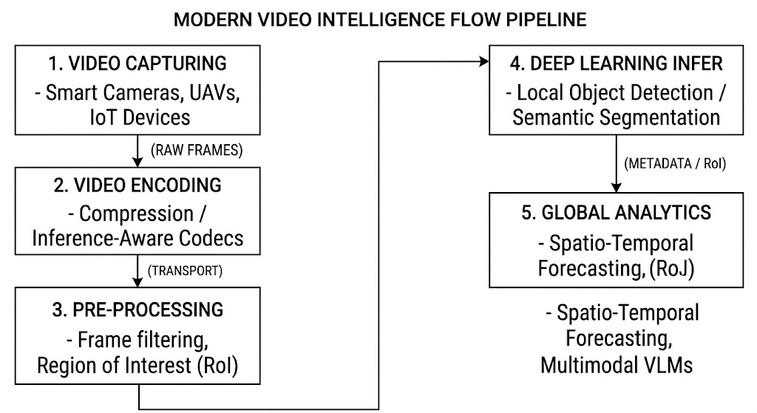

Example:

City-Scale Scalability
A 2026 study by Sharma et al. highlights the massive scalability of CETC systems through a city-scale traffic analytics deployment in Bengaluru.⁴
By pushing high-throughput detection to a distributed tier of heterogeneous edge accelerators (like Nvidia Jetson Orin devices), the system eliminates the need to transmit high-bandwidth video to the cloud.⁴ Instead, the edge devices extract compact flow summaries, which the cloud uses to power Spatio-Temporal Graph Neural Networks (ST-GNNs). This testbed effectively achieved stable ingestion of up to 2000 Frames Per Second (FPS) across the edge, easily sustaining forecasts for 1000 concurrent camera streams with near-zero latency.⁴

Orchestration

Multi-Agent Reinforcement Learning (MARL)
Edge nodes are resource-constrained and frequently suffer from workload imbalances one node might drop frames due to heavy traffic while a neighboring node sits idle.
To solve this, the EdgeVision framework utilizes an actor-critic Multi-Agent Reinforcement Learning (MARL) algorithm.⁵ Instead of relying on a centralized cloud scheduler, EdgeVision enables edge nodes to autonomously and cooperatively learn policies for model selection and request offloading.⁵

Performance Enhancements via EdgeVision
Compared to baseline heuristic scheduling models, the EdgeVision MARL approach provides massive systemic improvements.⁵
Performance Metric | Baseline Methods | EdgeVision (MARL) | Improvement / Reduction
Overall Performance | Standard | Optimized | + 33.6% to 86.4%
Video Frame Drop Rate | High | Near-Zero | - 92.8% Reduction

Inference-Aware Neural Codecs
Traditional video compression (like H.264) optimizes video for the human eye. However, machine learning models do not require aesthetic video; they require semantic data.
The VidIQ system introduces Inference-Aware Neural Codecs.⁶ Utilizing Deep Reinforcement Learning (DRL), VidIQ dynamically filters out redundant frames and only extracts mathematical reference relationships (motion vectors) for non-processed blocks.⁶ By encoding video specifically for machine inference rather than human viewing, VidIQ achieves a 6% to 21% improvement in accuracy while simultaneously yielding a massive 20% to 80% reduction in latency.⁶

Generative AI and VLMs at the Edge
The most recent leap in video analytics involves deploying Vision-Language Models (VLMs) across the edge-cloud fabric. A ground-breaking 2025 framework, VaVLM (Efficient Edge-Cloud Video Analytics With Vision-Language Models), utilizes VLMs to perform task-oriented semantic compression.⁷
When a user submits a natural language query, an edge-based VLM identifies the exact semantic Region-of-Interest (RoI) required to answer the query.⁷ The system truncates and discards all background or irrelevant data, transmitting only the highly localized RoI to a heavier cloud VLM for final reasoning.⁷

VaVLM Resource Reduction (Compared to Standard DNNs)
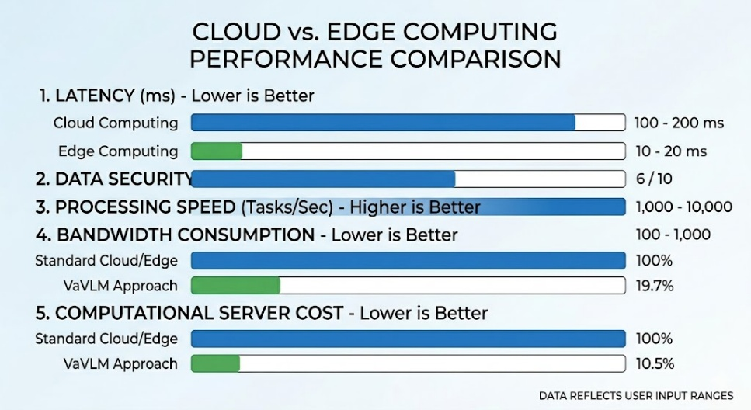
By transitioning from transmitting raw pixels to transmitting semantic intent, VaVLM achieves an 80.3% reduction in bandwidth and an 89.5% reduction in computational costs, fundamentally redefining network efficiency.⁷

Conclusion
Edge Video Analytics has moved past simple video offloading into an era of intelligent, decentralized collaboration. Through the implementation of multi-agent distributed routing, machine-centric neural codecs, and edge-deployed multimodal generative AI, these systems overcome historic bandwidth and computational limits. These innovations pave the way for real-time, privacy-preserving, and highly scalable cyber-physical systems.

References Used:
- ¹ Zheng et al. (2023). Edge Video Analytics: A Survey on Applications, Systems and Enabling Techniques.
- ² Data comparisons regarding latency and bandwidth metrics in Cloud vs. Edge environments.
- ³ Gong et al. (2025). A Survey on Video Analytics in Cloud-Edge-Terminal Collaborative Systems.
- ⁴ Sharma et al. (2026). Scaling Real-Time Traffic Analytics on Edge–Cloud Fabrics for City-Scale Camera Networks.
- ⁵ Gao et al. (2024). EdgeVision: Towards Collaborative Video Analytics on Distributed Edges for Performance Maximization.
- ⁶ Zhu et al. (2025). VidIQ: Inference-Aware Neural Codecs for Quality-Enhanced, Real-Time Video Analytics.
- ⁷ Zhang et al. (2025). VaVLM: Toward Efficient Edge-Cloud Video Analytics With Vision-Language Models.

Works cited
- Edge Video Analytics: A Survey on Applications, Systems and Enabling Techniques, accessed on April 12, 2026, https://www.researchgate.net/publication/374594845_Edge_Video_Analytics_A_Survey_on_Applications_Systems_and_Enabling_Techniques
- Edge Computing vs. Cloud Computing: A Comparative Analysis for Real-Time AI Applications - IJFMR, accessed on April 12, 2026, https://www.ijfmr.com/papers/2024/5/29316.pdf
- A Survey on Video Analytics in Cloud-Edge-Terminal Collaborative Systems - arXiv, accessed on April 12, 2026, https://arxiv.org/html/2502.06581v3
- Scaling Real-Time Traffic Analytics on Edge–Cloud Fabrics for City-Scale Camera Networks 1footnote 11footnote 1Accepted at TCSC SCALE Challenge 2026. To appear in the Proceedings of IEEE/ACM CCGRID Workshops, Sydney, 2026. - arXiv, accessed on April 12, 2026, https://arxiv.org/html/2603.05217v1
- EdgeVision: Towards Collaborative Video Analytics on Distributed Edges for Performance Maximization - ResearchGate, accessed on April 12, 2026, https://www.researchgate.net/publication/380671430_EdgeVision_Towards_Collaborative_Video_Analytics_on_Distributed_Edges_for_Performance_Maximization
- VidIQ: Inference-Aware Neural Codecs for Quality-Enhanced, Real-Time Video Analytics | Request PDF - ResearchGate, accessed on April 12, 2026, https://www.researchgate.net/publication/396942453_VidIQ_Inference-Aware_Neural_Codecs_for_Quality-Enhanced_Real-Time_Video_Analytics
- VaVLM: Toward Efficient Edge-Cloud Video Analytics With Vision-Language Models - IEEE Xplore, accessed on April 12, 2026, https://ieeexplore.ieee.org/iel8/11/4359969/10947590.pdf

